

PSHECC Newsletter
Dear parents and carers,
Welcome to another edition of our termly PSHECC newsletter. We hope it continues to keep you informed about learning across our Personal Development (PD), PSHECC and Relationships, Sex and Health Education (RSHE) curriculum. This edition includes a summary of our recent RSHE workshop for parents and carers, an update on the research interviews I continue to conduct with parents of children with complex needs, and some useful information about the recent changes to the statutory RSHE guidance announced by the Department for Education (DfE). As always, our curriculum is carefully adapted to meet the individual needs of every child while ensuring statutory requirements are fully met. Further information about our PSHECC, RSHE and Personal Development curriculum, including policies and curriculum overviews, is available on the school website. We hope you enjoy reading this newsletter and thank you for your continued support in helping our pupils become safe, healthy, confident and independent learners. Happy reading!
Sylwia Gryzia, Personal Development and PSHECC Lead
No. 6, July 2026
Summer Sun Safety ☀️
• Slip on sunscreen, pop on a sun hat and wear cool, comfortable clothing.
• Keep sipping! A named water bottle is a summer essential.
• Enjoy the sunshine, but remember that shade is the coolest place to play!

Rights Respecting Schools Silver Assessment
On 16 July, our school will welcome an assessor from UNICEF UK as part of our Rights Respecting Schools Silver: Rights Aware assessment. This is an exciting milestone in recognising the work we have undertaken to embed children's rights throughout school life and ensure that every pupil feels safe, valued and respected.
Over the past year, pupils and staff have worked together to strengthen our rights respecting culture through our Personal Development, PSHECC and RSHE curriculum. Children have explored what their rights mean in everyday life and how these are balanced with responsibilities. A particular focus has been placed on developing an understanding of consent, personal choice, boundaries and respecting the wishes and feelings of others. Pupils have been learning that everyone has the right to feel safe, to have their voice heard, and to make choices wherever possible. Our School Council has continued to play an important role in ensuring that pupils' voices are heard and that they can actively contribute to decisions that affect school life. During this year's Arts Week, children were also given the opportunity to choose from a wide range of inclusive creative activities, allowing every pupil to participate in experiences that matched their interests, strengths and individual needs. Promoting meaningful choice is an important part of respecting children's rights and celebrating inclusion.
The assessment day will include discussions with children, staff, governors and school leaders. We are delighted that pupils will have the opportunity to share their experiences alongside members of the School Council, the PSHECC Lead, the School Council Lead, governors, and both our current Headteacher and our newly appointed Headteacher. Their involvement reflects our shared commitment to ensuring that every member of our school community has a voice and plays a part in creating a safe, respectful and inclusive environment where all children can thrive. We are incredibly proud of the progress our school has made and look forward to showcasing our Rights Respecting journey on assessment day.

Department for Education DfE Updates to the RSHE Curriculum

From September 2026, all schools in England will begin teaching the updated statutory Relationships, Sex and Health Education (RSHE) curriculum published by the Department for Education (DfE). The revised guidance places a greater emphasis on helping children stay safe, healthy and prepared for modern life.
Key updates include a stronger focus on online safety, healthy and respectful relationships, consent and personal boundaries, mental wellbeing, and age appropriate teaching about physical development and puberty. The guidance also highlights the importance of working in partnership with parents/carers and ensuring that learning is adapted to meet the needs of all pupils, including those with SEND. Schools are also expected to be more transparent about what is taught and to share curriculum information and resources with families.
At Fort Royal, many of these principles are already embedded within our Personal Development and RSHE curriculum. We will continue to review our provision to ensure it reflects the latest statutory guidance and meets the needs of all our pupils.

Avoidance as a Systemic Barrier: Examining How Professional Communication Shapes Ambiguous Loss in Parents of Children with Complex Needs
Over the past few months, I have continued conducting interviews with parents of children with complex needs to better understand their experiences of navigating education, healthcare and support services. Although every family's journey is unique, many parents shared similar experiences and highlighted the importance of compassionate communication, collaborative working and feeling genuinely listened to by professionals. Parents described how positive relationships with professionals can make an enormous difference during what can often be an emotionally demanding journey. They valued honesty, consistency and being included in decisions about their child's education and wellbeing. Many also spoke about the importance of professionals recognising not only their child's needs but also the expertise and knowledge that parents bring. One of the strongest themes to emerge has been the overwhelmingly positive feedback about Fort Royal. Parents repeatedly expressed their gratitude for the dedication, kindness and professionalism shown by staff. Many described teachers, teaching assistants and the wider school team as "heroes", recognising the difference they make every day through their patience, commitment and unwavering belief in every child's potential. Families particularly valued the close partnership between home and school, the personalised support provided to each child and the genuine care shown to both children and their parents. A heartfelt thank you to every parent who has generously shared their experiences. Your voices are helping to deepen our understanding of how professional communication shapes the experiences of families raising children with complex needs and will contribute to improving practice for future generations.
Sylwia Gryzia, M.Ed., PSHECC, PD and foundation curriculum lead

PSHECC, PDC and foundation curriculum lead

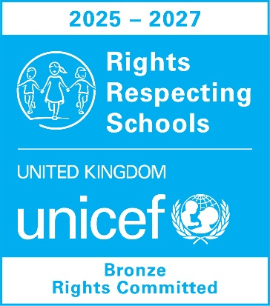
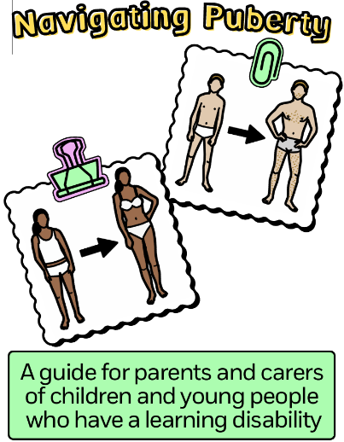
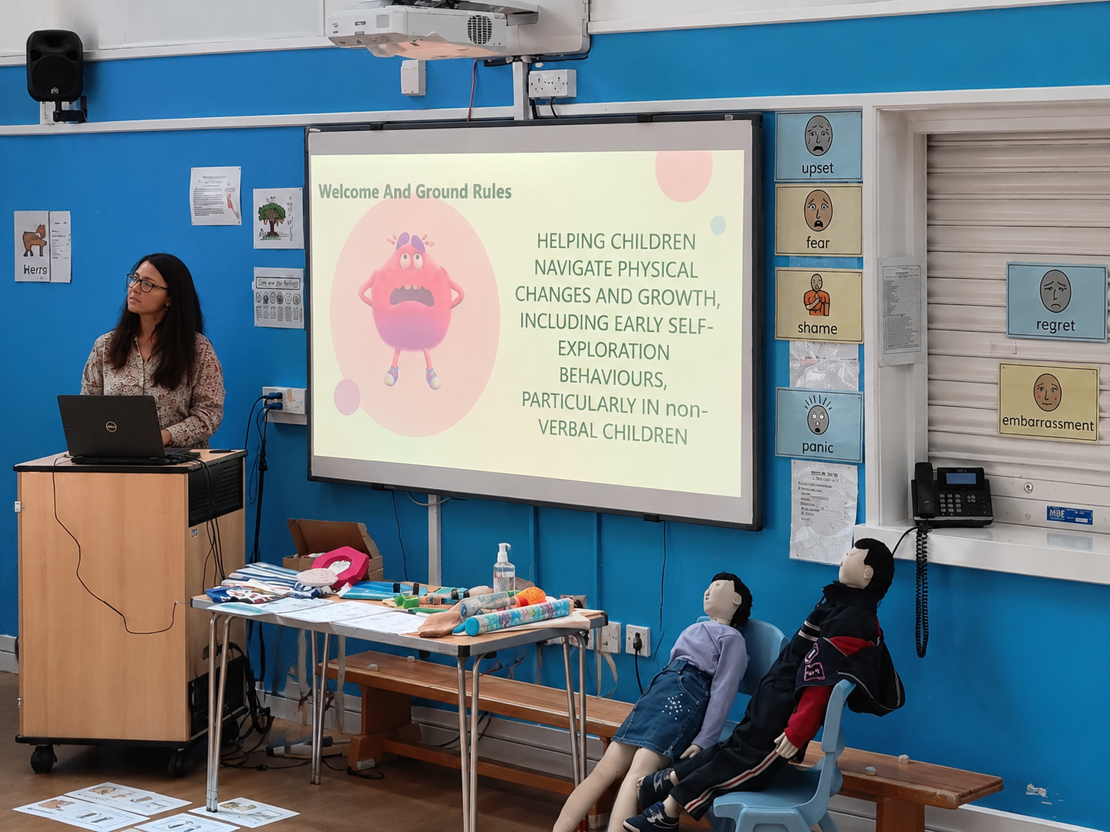
RSHE workshop
A huge thank you to all the parents who attended our recent RSHE workshop and for the wonderful feedback we have received so far. We are delighted that so many of you found the session informative, practical, and reassuring. Your willingness to engage in open discussions, ask thoughtful questions, and share your experiences created a supportive and welcoming atmosphere. We greatly value the strong partnership between home and school and appreciate your commitment to supporting your children's personal development. During the workshop, we explored how to support children as they experience physical changes and puberty, while developing an understanding of personal boundaries, privacy, and respectful relationships. We also discussed how behaviours such as self-exploration, removing clothing, or seeking sensory input can often be a natural part of development, particularly for children with SEND. Practical strategies were shared to help parents respond calmly, consistently, and without shame, while teaching children appropriate boundaries and promoting independence. For parents who were unable to attend, one of the key messages was that children learn best through repetition, clear expectations, and positive guidance. Using simple language, visual supports where appropriate, and consistent routines at home and school helps children develop confidence, independence, and a healthy understanding of privacy and personal safety. Thank you once again to everyone who attended and contributed to such a positive session. Your continued support helps us provide children with consistent messages both at home and at school, giving them the knowledge and skills they need to stay safe, healthy, and confident. We look forward to welcoming more parents to future RSHE workshops.

