🎨 Arts Week 2026

Our Rights. Our Voices. Our Community.
Dear Parents and Carers,
During the week commencing 18th May, we will be again celebrating our famous Arts Week in school.
This year, our theme is linked to the UN Convention on the Rights of the Child, focusing on four important articles:
- Article 12 – The right to share views and be listened to
- Article 13 – The right to express thoughts and ideas
- Article 29 – Education should help children respect others and the wider world
- Article 31 – The right to play and take part in creative and cultural activities
As we are working towards achieving the Silver Rights Respecting Schools Award, Arts Week provides a wonderful opportunity to show how children’s rights are embedded in our learning and wider school life.
Throughout Arts Week, children will:
- Share their voices
- Take turns and listen to others
- Work together creatively
- Connect their learning with the wider community
Through art, music, drama and other creative activities, pupils will explore how their voices matter and how creativity helps us build respectful and inclusive communities.
We look forward to celebrating the children’s work and sharing their wonderful creations with you.
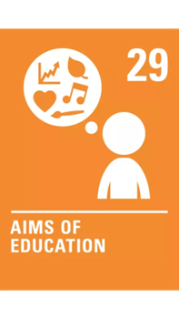
Kind regards,
Sylwia


