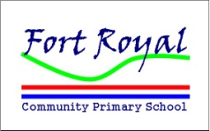
P.E Long Term Planning Cycle

Autumn 1 | Autumn 2 | Spring 1 | Spring 2 | Summer 1 | Summer 2

Foundation Stage  Cycle A | The senses | Food around the world | Pets | Toys | Bears | Transport
Foundation Stage  Cycle B | All About Me | People who help us | Nursery Rhymes | Farms | Buildings | Water, Water Everywhere

Key Stage 1  Cycle A | Games | Dance | Dance | Gymnastics | Gymnastics | Athletics
Key Stage 1  Cycle B | Games | Gymnastics | Dance | Gymnastics | Dance | Athletics

Key Stage 2  Year 3&4  Cycle A | Games | Dance | Gymnastics | Dance | Games | Athletics
Key Stage 2  Year 3&4  Cycle B | Games | Gymnastics | Dance | Gymnastics | Dance | Athletics

Key Stage 2  Years 5&6  Cycle A | Games | Dance | Gymnastics | Games | Dance | Athletics
Key Stage 2  Years 5&6  Cycle B | Games | Dance | Gymnastics | Dance | Games | Athletics

